Lab - IP Address Subnetting 2

You are tasked to design a new network for a small company, which is organized into the following departments:

- Sales department with 100 staff
- Tech Support department with 40 staff.
- Admin department currently with 10 staff.
- WAN point-to-point links to connect the 3 routers.

Subnet 4
Subnet 5

S2/0
x.x
RouterA
S2/0
x.x
S3/0
x.x
S2/0
x.x
RouterB
RouterC

B
C
A

Fa0/0
x.x
Fa0/0
x.x
Fa0/0
x.x

switch
switch
switch

PC1
PC3
PC2

Subnet 0
Subnet 1
Subnet 2

Sales
Tech Support
Admin

You are assigned a Class C network address: 192.168.10.0 / 24. Using Variable Length Subnet Mask (VLSM), design the IP addressing scheme for the needed subnets, based on the maximum number of staff in each department, plus the WAN links.

Steps to do VLSM subnetting:

    - Rank the subnets from the biggest requirements to the smallest – in this case:
Sales (100) then Tech Support (40) then Admin (10), followed by WAN links.

    - Start the VLSM subnetting with the largest requirement. Use the formula:

No. of host = 2^{H} – 2 (where H = no. of host bits)

2^{H} – 2 ≥ host requirements

Calculate the required no. of host bits, H for the above requirements.

    - The subnet prefix is the number of network bits = 32 – H

    - Calculate the new subnet mask, based on new no. of network bits.

    - Calculate the new subnet addresses & list the prefix with the subnet address.

    - Assign the 1st subnet address to the 1st group and the next subnet address to the next smaller group.

    - Calculate the Broadcast address for the 1st group.

    - Then repeat Steps 2 to 7 for the next requirements.

Part 1: Working for Subnet calculations

Given: 192.168.10.0 /24 → Network = 24 bits & Host = 8 bits

- Sales – requires 100 hosts (for 100 staff)

Number of Host bits required:
No. of host = 2^{H} – 2 >= 100 → 2⁷ – 2 = 128 – 2 = 126 (OK, since > 100)

No. of host bits, H = 7 bits → Network = 32 – 7 = 25 bits

Network = 25 bits → Prefix = /25

New Subnet mask:
Subnet mask: Network bits set to ‘1’ & hosts bits set to ‘0’

New Subnet mask: /25 → 11111111.11111111.11111111.10000000
255.255.255.128

Network increment (Using magic no.) → 256 – 128 = 128

Subnet addresses: (host bits all ‘0’)
25 bits network 7 bits host

- 11000000.10101000.00001010. 00000000 → 192.168.10.0 /25
- 11000000.10101000.00001010. 10000000 → 192.168.10.128 /25

Assign the 1st subnet, subnet 0 (192.168.10.0 /25) to the Sales dept.

Next, assign the next subnet (192.168.10.128 /25) to the next requirement.

Broadcast address calculations:
Broadcast address → set all host bits to ‘1’

11000000.10101000.00001010. 01111111 → 192.168.10.127 /25
Fill up the Network Address Table

Subnet Name | Subnet Address /Prefix | 1st host address | Last host address | Broadcast Address
Sales (100) | 192.168.10.0 /25 | 192.168.10.1 | 192.168.10.126 | 192.168.10.127
Tech (40) | 192.168.10.128 /26 | 192.168.10.129 | 192.168.10.190 | 192.168.10.191
Admin (10) | 192.168.10.192 /28 | 192.168.10.193 | 192.168.10.206 | 192.168.10.207
WAN1 | 192.168.10.208 /30 | 192.168.10.209 | 192.168.10.210 | 192.168.10.211
WAN2 | 192.168.10.212 /30 | 192.168.10.213 | 192.168.10.214 | 192.168.10.215

(Note: Refer to VLSM worksheet at the last page of this labsheet for calculations for all the subnets address calculations).

Part2 : Fill up the Addressing Table

(Note: Use the 1st usable IP address for each router’s Ethernet interface & next address for the PCs).
By Rows first

Device | Interface | IP Address | Subnet Mask | Default Gateway
RouterA | Fa0/0 | 192.168.10.1 | 255.255.255.128 | N/A
RouterA | S2/0 | 192.168.10.209 | 255.255.255.252 | N/A
RouterB | Fa0/0 | 192.168.10.129 | 255.255.255.192 | N/A
RouterB | S2/0 | 192.168.10.210 | 255.255.255.252 | N/A
RouterB | S3/0 | 192.168.10.213 | 255.255.255.252 | N/A
RouterC | Fa0/0 | 192.168.10.193 | 255.255.255.240 | N/A
RouterC | S2/0 | 192.168.10.214 | 255.255.255.252 | N/A
PC1 | NIC | 192.168.10.2 | 255.255.255.128 | 192.168.10.1
PC2 | NIC | 192.168.10.130 | 255.255.255.192 | 192.168.10.129
PC3 | NIC | 192.168.10.194 | 255.255.255.240 | 192.168.10.193

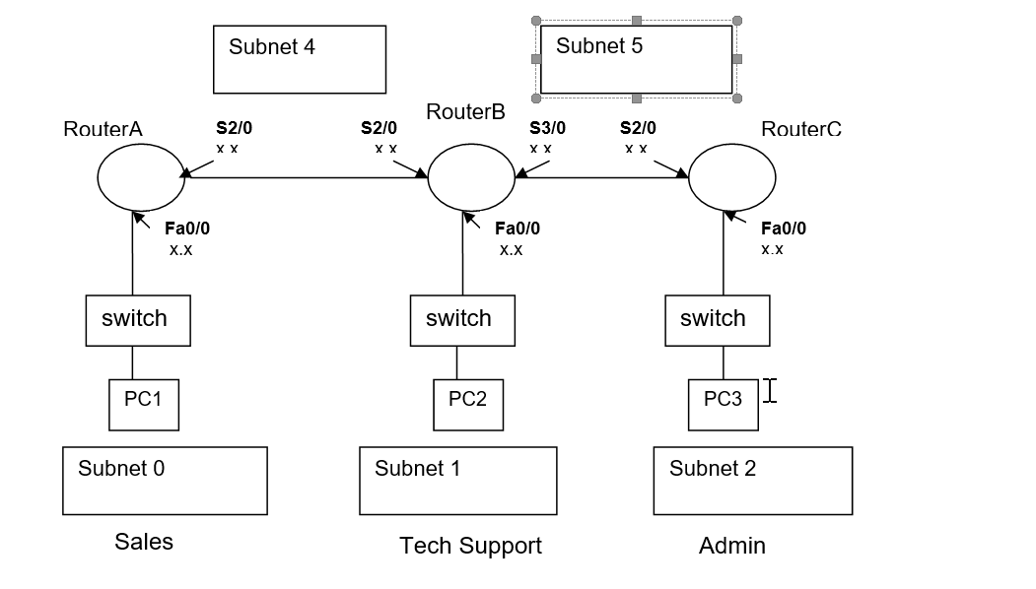

Given: 192.168.10.0 /24 → 24 bits network & 8 bits host
By columns first

Name of LAN/WAN | No of hosts needed | No of host bits | subnet mask in prefix format | subnet mask in dotted decimal format | magic no | subnet address | first valid IP | last IP | broadcast IP
Sales | 100 | 7 | 32 - 7 = 25 | 1000 0000 = 128 | 256 - 128 = 128 | 192.168.10.0 | 192.168.10.0 | 192.168.10.126 | 192.168.10.127
Tech | 40 | 6 | 32 - 6 = 26 | 1100 0000 = 192 | 256 -192 = 64 | 192.168.10.128 | 192.168.10.129 | 192.168.10.190 | 192.168.10.191
Admin | 10 | 4 | 32 – 4 = 28 | 1111 0000 = 240 | 256 -240 = 16 | 192.168.10 .192 | 192.168.10.193 | 192.168.10.206 | 192.168.10.207
Wan 1 Router A to Router B | 2 | 2 | 32 – 2 = 30 | 1111 1100 = 252 | 256 – 252 = 4 | 192.168.10.208 | 192.168.10.209 | 192.168.10.210 | 192.168.10.211
Wan 2 Router B to Router C | 2 | 2 | 32 – 2 = 30 | 1111 1100 = 252 | 256 – 252 = 4 | 192.168.10.212 | 192.168.10.213 | 192.168.10.214 | 192.168.10.215
2^7=128 |  |  |  |  |  | 192.168.10.216

